

Funding Assistance for Civil Contractors Members
Last updated October 2025

If you know of other funding opportunities that may benefit civil contractors, please let us know at info@civilcontractors.co.nz
CENTRAL GOVERNEMENT PRODUCTS
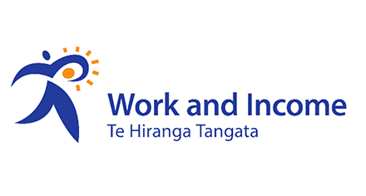
MANA IN MAHI
Take part in Mana in Mahi to get paid while you train to do a job you love.
With Mana in Mahi you can:
- get support to kick start your career
- earn while you learn
- gain recognised qualifications.

How to apply
If you're already talking to us about finding or getting ready for work,
ask about Mana in Mahi.
We'll aim to contact you within 5 working days.
Mana in Mahi - Strength in Work - Work and Income
https://www.workandincome.govt.nz/products/a-z-benefits/mana-in-mahi.html
FLEXI-WAGE
What's Flexi-wage
Flexi-wage helps job seekers to get the skills they need to meet the requirements of a job.
Employees can get training and ongoing support if needed, and employers can get a wage contribution to help them pay their employees. The job must continue after the Flexi-wage has finished.
Support from us can include:
- a contribution to your wages - we'll pay this to your employer
- training
- ongoing support.
We'll talk to your employer about what you need and how we can help.
Flexi-wage – job seeker information - Work and Income
https://www.workandincome.govt.nz/products/a-z-benefits/flexi-wage.html
SKILLS FOR INDUSTRY
This is a specific programme that employers can access if they are recruiting and needing to train multiple staff at the same time.
Skills for Industry - Work and Income
APPRENTICESHIP BOOST
As part of the Wellbeing Budget 23 / 23
The payment is made directly to employers. It means apprentices can keep earning while training towards their qualifications.
Payments will continue for a maximum of 24 months per apprentice, or until the initiative ends.
Apprenticeship Boost - Work and Income
CONNECTED
This government site covers several additional funding opportunities for employers. There is a specific focus on funding for people with disabilities as well as opportunities for Māori and Pasifika.
Money or support to train | Connected

Fees Free Tertiary Education and Training was introduced on 1 January 2018. It changes across government cycles. Please check the website.
From 2025, it's a "final-year Fees Free" entitlement, which covers the final year of a tertiary qualification or the final two years of work-based learning, up to $12,000. You must pay your fees upfront when you start, and then claim your entitlement after you have completed your qualification.
How it works in 2025
- For first-time students: If you are starting your first eligible qualification on or after January 1, 2025, you can get Fees Free for your final year.
- Payment: You will need to pay your fees upfront when you enrol.
- Claiming Fees Free: After you complete your qualification, you can apply to get your fees reimbursed. The application for this starts from January 15, 2026, through the Inland Revenue (IRD) website.
- Limited to one-time use: You can only get this entitlement once.
- Eligibility: You must meet the qualification and residency requirements.
- Previous study: If you have already completed a qualification in New Zealand or overseas, you will likely not be eligible, but there are some exceptions for learners continuing in 2024.
Who to contact
The Customer Contact Group is available to answer Fees Free queries, via 0800 601 301 or customerservice@tec.govt.nz. You can also contact your relationship manager or advisor.
Fees Free | Study or train fees-free
Early Response (MSD)
This service is operated out of MSD. This initiative ensures people who face losing their jobs continue to benefit from early engagement that supports their swift return to work, preventing wage scarring and negative economic, social and health impacts.
Early Response Redeployment Support/Rapid Return to Work - Budget 2023 - Ministry of Social Development
Jobs and Skills Hubs
Jobs and skills hub exist to directly connect education and employment opportunities. Currently they exist in the North Island only in Auckland, Hawkes Bay and Lower Hutt. They operate a range of programmes and offer employment opportunities. A jobs and skills hub will also be able to assist with funding requirements.
Jobs and Skills Hubs
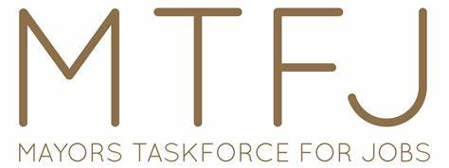

The Mayors Taskforce for Jobs (MTFJ) is a nationwide network of New Zealand’s Mayors, working together towards the vision of all young people 16-25 engaged in employment, education, training, or other positive activity in their communities.
The Youth to Work Strategy works to improve local solutions to pathway development, access, retention and achievement of youth outcomes within education, training and employment.
This strategy is driven by local MTFJ groups across the country. Each group is different but usually includes: The Mayor, employers, local iwi, government agencies, youth organisations, representatives from the educational and training sector and young people themselves.
Each group works towards achieving our vision by taking these 6 steps:
1. Identify – We identify local demand for skills from employers and analyse local opportunities or obstacles to youth employment;
2. Connect all young people to good support – We encourage the connection of ALL young people to appropriate support systems in our local communities. We encourage quality relationships, good information sharing and working with our stakeholders to influence positive choices for ALL youth;
3. Facilitate work readiness – We encourage a coordinated and collaborative approach to educate and train young people to meet the needs of local employers and industry. This is where supply meets demand;
4. Job opportunity and employer commitment – We help secure real job opportunities by finding out what local employers need and setting up discussions between employers, schools, training providers and support services. We support opportunities for voluntary work experience, paid employment, apprenticeships, cadetships and gateways to build skills, networks and opportunities for young people to participate in the wider community;
5. Mentor – We take a shared approach to mentoring young people in and out of the workplace to ensure positive results; and
6. Celebrate – We recognise and celebrate youth and employer achievements by establishing community events and activities that acknowledge young people, employers and those contributing to a positive change.

Home | Mayors Taskforce for Jobs

LITERACY AND NUMERACY SUPPORT

Many employees and employers are reluctant to engage in work based learning due to literacy issues. There is help. Direct approaches can be made to Literacy Aotearoa who can assist people grow their literacy skill. These are free and the information can be found below. There are also many other literacy support providers who will be local to your area. Use your standard search engine to find out additional assistance regionally.

Literacy Aotearoa

